Balance of Payments Reporting - Lesotho
Test Strategy
Revision History
Date | Version | Author | Description
11/09/2020 | 0.1 | M Byker | Draft

Table of Contents
1. Scope 4
1.1. Business Landscape 4
1.2. Objective 4
1.3. Technical Landscape 5
1.4. Business Process Flow 5
1.5. Testing Scope 5
1.6. Testing activities carried out 6
2. Test Approach 7
2.1. Process of testing (Scrum aligned) 7
2.2. Deliverables 7
2.3. Roles and Responsibilities 8
2.4. Fulcrums 9
2.5. Defect Management 10
2.6. Reporting 10
3. Test Environment 11
4. Tools 12
4.1. JIRA 12
4.2. STEP 12
5. Methodology 13
5.1. Backlog Refinement 13
5.2. Sprint planning 13
5.3. Daily Scrum 13
5.4. Sprint Demo 13
5.5. Sprint Retrospective 14
6. Risk & Issues 15
7. Review and Approvals 16

Scope

Business Landscape
Balance of Payments Reporting (BoP Reporting) is an electronic message system used to report cross-border transactions to the South African Reserve Bank (SARB).

Lesotho is upgrading the BOP reporting to BOPCUS 3. Currently, we already have BOPCUS 3 reporting in Namibia, but Lesotho has requested new rules for Lesotho BOPCUS 3.

In Namibia BOPCUS 3, BOP is not created for Non-Reportable transactions and eventually not reported. Lesotho has requested a different approach for reportability, the request it to create BOP for Non-Reportable transactions also but with Category code as ZZ1. These records will be submitted to Vanguard but not further to CBL.

All the reportable transaction will be reported same as Namibia.

Objective
This strategy will aim to outline:
- Step by step process we will follow to get from requirements analysis to completed test
- How we will test
- What we will need
- Who we need to connect with to get us what we need in the shortest time
- What we will test (Scope)

Technical Landscape
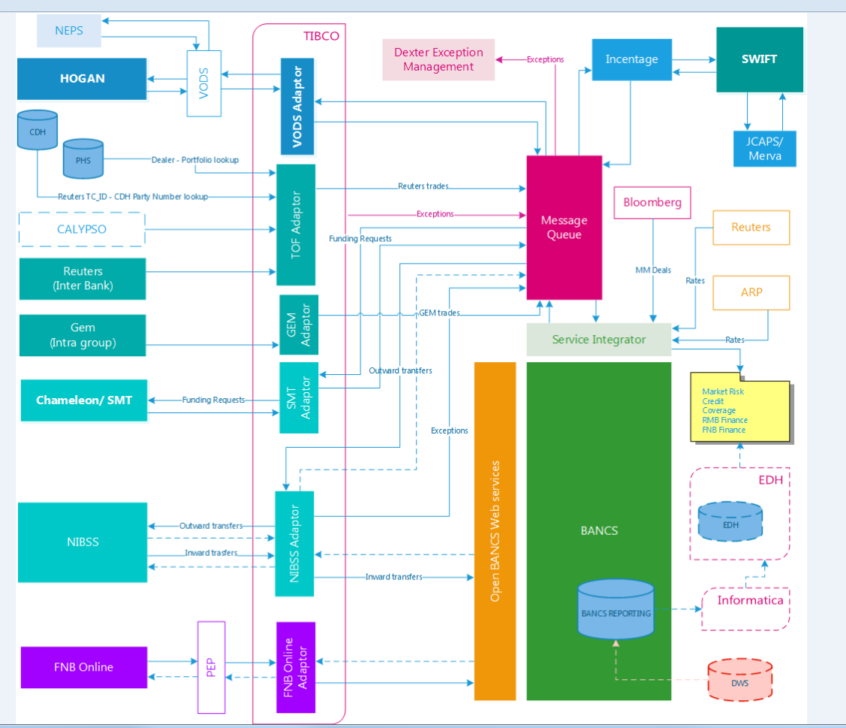

Business Process Flow

Testing Scope
- We are going to verify that BOPCUS 3 changes for Lesotho has been successfully implemented
- Transactions that needs to be reported are reported
- Transactions that should not be reported are not reported
- All the relevant information for incoming and outgoing payments are captured for reporting purposes
- Scope includes positive (happy days scenarios) for Reporting rules for Lesotho, Validation rules, Reportable transactions, mappings, and BoP Codes for Lesotho
- Scope will also include a subset of negative scenarios (deliberately broken messages inserted to see how they are processed)

Testing activities carried out
# | Actions | Deliverable
1 | Requirements Analysis (Sprint 1)
a | Reporting Rules
b | Technical Specifications (SARB)
c | Validation Rules
d | Lesotho Reportable Transactions
e | Category mapping - Lesotho
f | BOP Codes for Lesotho
g | Manual forms - Incoming
h | Manual forms - Outgoing
i | Architecture Diagram
j | Three Amigos
2 | Test Process Design (Sprint 1)
a | How will we gather requirements
b | How will we execute the testing project
c | How will we execute testing
d | How will we report defects
e | How will we report test results
3 | Test Case Specifications (SbE) Design (Sprint 1)
4 | Tools
a | Living Documentation
b | STEP / SOAP UI
c | JIRA
5 | Test Execution (Sprint 2)
a | communicate the strategy
b | co-ordinating the testing effort

Test Approach

Process of testing (Scrum aligned)

Deliverables
Deliverable | Date | Responsible
QA Strategy / Plan | In progress | QA Lead
Estimations | In progress | QA Lead
WBS / Backlog | In progress | QA Lead
Test Architecture Design |  | SQE
Requirements Extract | In progress – this is aligned with the backlog creation | SQE / QA Lead
Example Specifications |  | SQE
Test Packs / Living specifications |  | SQE
End of Phase Reporting | (To be issued at regular intervals as the sponsor, project manager or business has specified) | QA Lead/ SQE
Project Close out | (Collation and summary of all Test Reports at different stages of the project) | QA Lead / Project Manager

Roles and Responsibilities
Role | Responsibilities | Resource(s)
QA Lead | - Produce the QA Strategy  - Produce the WBS  - Produce WBS (ak.a. Backlog)  - Manage test deliverables according to the project plan.  - Track and manages resolution of issues as and when they arise.  - Manage availability of testing environment for the duration of the test phase.  - Assist with the development of a framework for successful testing  - Co-ordinate testing resources  - Manage the quality of the deliverables  - Communicates Test Status  - Document Test Summary Report  - Produce the Application Readiness Reports as required by the Project Manager  - Liaise with Project Manager Business Analysts, business, TAs and other role players w.r.t. requirements and issues arising out of testing | Martin Byker
SQE | - Test analysis identifying user stories relevant to the business.  - Develop test cases  - Execute test cases  - Log results  - Defect logging and management  - Contribute to Test Summary and Application Readiness Reports | Lungile Maseko
Technical Test Analyst | - Analyse message types, file and API layouts  - Create the framework for service virtualisation  - Create reusable testing scenarios  - Create reusable dataset supporting the execution of the test scenarios  - Create repeatable and traceable user stories that can be replayed and verified at different points in the trade flow.  - Verify transactional data flow:  - Defect logging and management  - Contribute to Test Summary and Application Readiness Reports | Marcus Henry / Anthony Mpofu

Fulcrums

Service Virtualization and API Software Quality Engineering
Implementing service virtualisation will complement our approach to create, maintain and execute test scenarios for successful continuous integration. In so doing we will deliver test scenarios that improve the quality of code being deployed.
We will also use this to provide test data for specific scenarios identified that improves the quality of code by building quality in from the analysis stage of the project. This will be used for creating smoke tests as well as an automated regression pack.

STEP
The Services Testing Enablement Platform can be used to drive message-based testing by providing a virtualized environment and removing the need or reliance of environment variables that could be detrimental to delivery of test results.

Specification by Example
We need to verify the translation of business ideas to features and functions into code. The process provides an opportunity to build a common understanding of a specific scenario by all role players by using examples to clarify understanding.

We use the Power of 3 perspectives:
i. Business Analysis
ii. Development
iii. Quality Assurance

Peer review of the Specification-by-Examples facilitates better collaboration within the team:
-Given [As a DS I want to use function “X”]
-When [using these parameters]
-Then [the expected result is …]

In formulating SBE’s, we create reusable assets which compliments Continuous Integration, continuous SQE and automation of scenarios through converting them to executable specifications. The executable specifications will be expanded upon later in the document.

Adopting Specification by Example enhances communication on business needs as defined in the design phase.
We get to the correct depth of understanding of a function as a team.

SBE’s also gets adopted as acceptance criteria for a feature or function to be signed-off by the team.

Defect Management
Defects are managed according to the following steps:
- Discovery
  - In the discovery phase, the project teams must discover as many defects as possible, before the end customer can discover it. A defect is said to be discovered and change to status accepted when it is acknowledged and accepted by the developers
- Categorization
  - Defect categorization help the software developers to prioritize their tasks. That means that this kind of priority helps the developers in fixing those defects first that are highly crucial.
- Resolution
  - Defect resolution process starts with assigning defects to developers, then developers schedule the defect to be fixed as per priority, then defects are fixed and finally developers send a report of resolution to the test manager. This process helps to fix and track defects easily.
- Verification
  - After the development team fixed and reported the defect, the testing team verifies that the defects are resolved.
- Closure
  - Once the defect is fixed and retested, it is closed.

Reporting
The project will be ran on the DevOpsQA instance of JIRA, linked to Tempo in order for the team to be able to track time worked. This is to ensure that external Managed Services resources accurately keep track of time and meterial for billing purposes. Further to this, using a Kanban instance on JIRA, we can track the following:

Flow Time | How long did it take for this item (feature/Backlog item/Defect) get through the value stream? (Total Active Time + Total Waiting Time)
Wait Time | How much wait time was there for defects, environment unavailability?
Value Chain Efficiency (measure of getting it right the first time) | Total active Time/Flow Time
Load | Number of items in progress (features/Automation backlog items/Defects)
Velocity | Number of items completed (features/Automation backlog items/Defects)

Test Environment
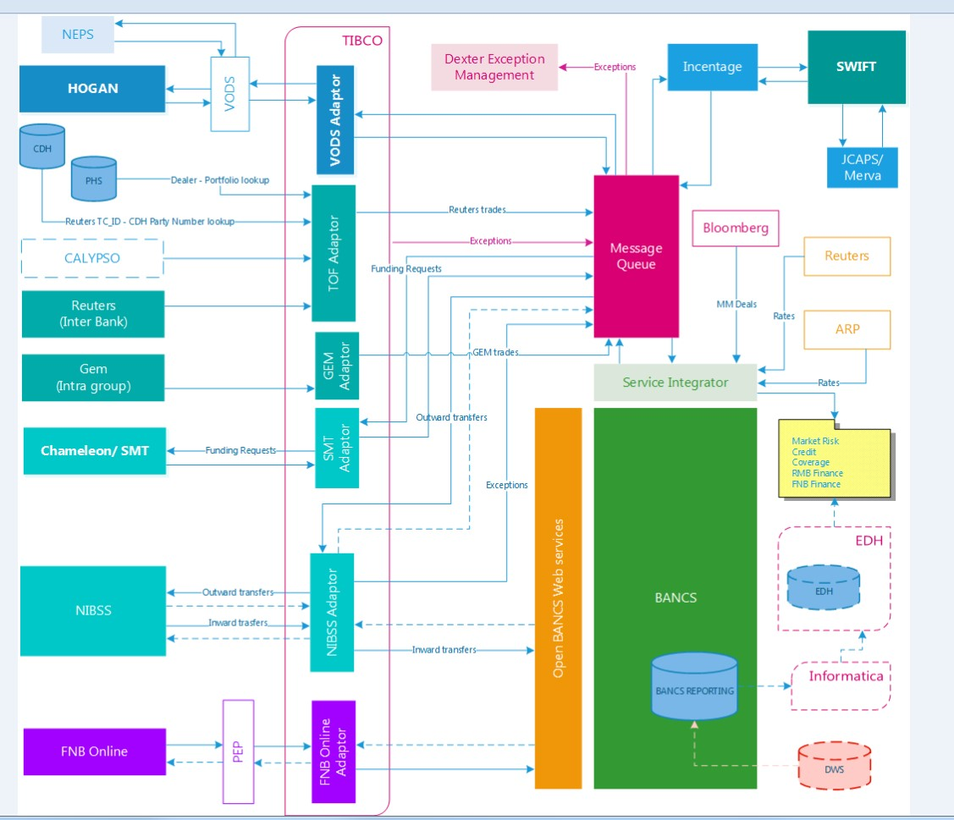

The above environment is where the solution will live in and be operational in.
The business flow of messages are explained in the video below:
EXPORTS
https://www.rmb.co.za/videos/solutions/bop/exports.mp4
IMPORTS
https://www.rmb.co.za/videos/solutions/bop/imports.mp4
THIRD PARTIES
https://www.rmb.co.za/videos/solutions/bop/third-party.mp4

Tools

JIRA
Atlassian JIRA will be used to manage and drive the project. The JIRA project can be accessed below:

https://devqa.atlassian.net/secure/RapidBoard.jspa?projectKey=BRU&rapidView=31

If access is required, please let the QA Lead know.

STEP
STEP refers to the Services Test Enablement Platform, a virtualized environment that essentially simulates up and downstream systems, thus removing dependencies on these systems and effectively validating message content. This will be ideal for the verification of Incoming payments and outgoing payments in the BoPCUS 3 upgrade for Lesotho:

STEP
STEP
STEP
BOPCUS

Methodology

Backlog Refinement
Once the requirements extract is completed, each extracted requirement will then be refined and selected for the backlog, for work to commence.

The backlog will consist of extracted requirements from the following documents:
- Reporting Rules
- Technical Specifications (SARB)
- Validation Rules
- Lesotho Reportable Transactions
- Category mapping - Lesotho
- BOP Codes for Lesotho

It will also include, specifically for Sprint 1, discoveries around the system architecture to enable STEP. This is now referred to as discoveries, because part of sprint 1 is to uncover and discover more.

Sprint planning
Refined backlog items are selected and added to the Sprint backlog. There are 2 Sprints planned.
- The first sprint is to build and develop test cases, scripts, and prepare STEP for BoPCUS 3.
- The seecond sprint is the test execution and test coordination sprint
Sprints will have a 2 (working week) project horizon

Daily Scrum
The team will have a daily scrum to provided each other with updates, answering:
- What did I do yesterday?
- What am I doing today?
- What is holding me back?

The daily Scrum will be held daily, at the same time, via MS Teams.

Sprint Demo
Closer to the end of each sprint, the team will be having a demonstration of work and deliverables achieved. This will be in line with the Sprint goals, which the suggested goals are set out below:
- Sprint 1: Build testable scenarios (either for manual injection, or for STEP)
- Sprint 2: BoPCUS 3 for Lesotho validated and verified ready for implementation

Sprint Retrospective
At or near the end, and before we embark on the sprint planning for the second sprint, we will have a retrospective. The retrospective will have the following prime directive:

Regardless of what we discover, we understand and truly believe that everyone did the best job they could, given what they knew at the time, their skills and abilities, the resources available, and the situation at hand.

The purpose of the Prime Directive is to assure that a retrospective has the right culture to make it a positive and result oriented event. It makes a retrospective become an effective team gathering to learn and find solutions to improve the way of working.

The purpose of the retrospective is to review what we just did, and how we can improve on it for the next sprint.

Risk & Issues
- Cost risk: escalation of project costs due to poor estimation accuracy and scope creep
  - Risk: Test design and execution is taking significantly longer than anticpiated
  - Mitigation: Apply Risk based test approach, OR review test design and use Boundary value analysis – NEVER add more resources if you can help it. More people require onboarding.
- Schedule risk: Slippages in schedule
  - Risk: The development team delivers late, or did not perform unit testing
  - Mitigation: Risk based test approach to reduce test timelines. Amend implemetstion scope. Change go live date
- Operational risk: Process problems such as procurement, production, and distribution.
  - Risk: Team members are allocated on other projects
  - Mitigation: Delay implementation and amend project timelines / use and leverage existing infrastructure / resources, where possible
- Hazard risks: acts of God, vandalism, sabotage, terrorism; labor strikes; civil unrest
  - Risk: Covid19
  - Mitigation: Social distancing, non-pharma interventions (sanitization of workspaces and hands, face coverings, remote work with collaboration tools)

Review and Approvals
We the undersigned agree to the project content outlined herein.

Name: Name:
Title: Title:

Name: Name:
Title: Title:

Name: Name:
Title: Title:

Name: Name:
Title: Title:

